RIW JSX Rules
For Every Team Member to Use to Maintain a Consistent JSX Structure Across Pages/Components.

File and Component Naming
- One React Component per file
- Component files use PascalCase (ie UpperCamelCase) $→$ MorphingLogo.jsx
- Default export must match the filename $→$ export default function Home() { … }

Import Order
- Keep Imports at the Top of every Component
- Structure is:
- React Hooks $→$ import { useState, useEffect, useRef } from "react"
- Third-Party Libraries $→$ import axios from "axios"
- Assets (images, icons, CSS) $→$ import logoUrl from "../assets/logoimgbw.png"
- Local components or utilities $→$ import Footer from "../components/Footer"
- Do NOT use string paths like “src/assets/…” in JSX. Always import the asset.

Quotes and Semicolons
- We use semicolons (Java style) for clarity
- Use double quotes for
- JSX attributes $→$ className=“home-page”
- JS strings $→$ const title = “Rooted in Water”

Component Structure
- Use this order inside a component:
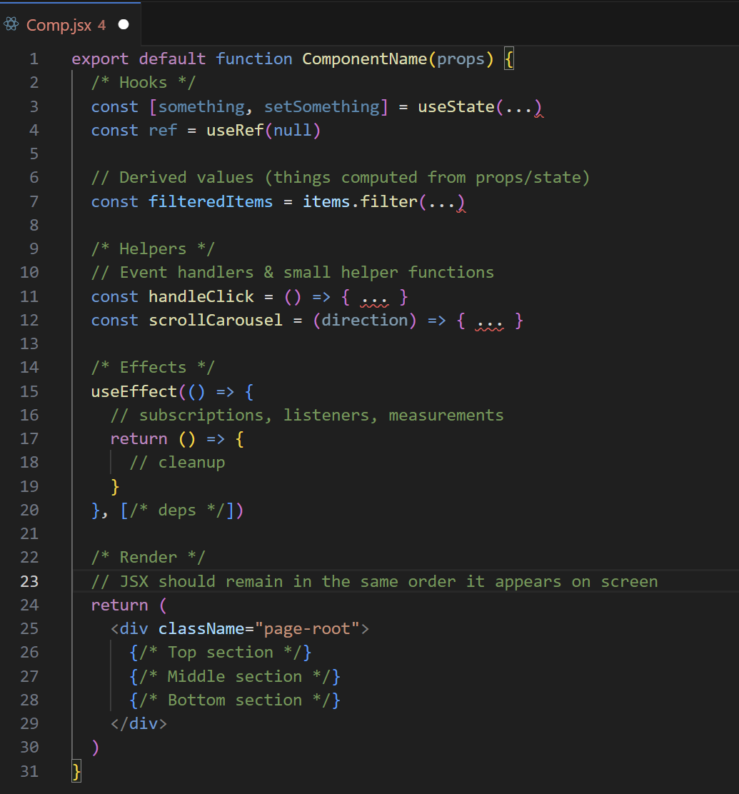

Layout and DOM Order
- General Rule: Visual (on WebApp) Order == JSX Order
- So if the page shows Top Bar, Hero Section, Content Grid, Footer, then JSX must follow the same sequence top to bottom.
- For page components:
- Each top-level page should have a top class $→$ className=“home-page” for Home.jsx
- Each top-level page should have a main .container for content alignment

Buttons, Links and Forms
- Buttons must have a valid type: “button”, “submit” or “reset” $→$ <button type="button" className="pill-button"> Search </button>
- Don’t invent custom type values (no type=“la-button”), use className for that
- Links must use <a> for navigation (not <button>!)

Classes and Naming
- Use className (never just class) in JSX
- Name structure classes by role:
- Page roots $→$ home-page, search-page
- Layout containers $→$ container, footer-top, footer-bar
- Functional elements $→$ pill, pill-button, maps-topbar
- Avoid duplicating multiple .container divs nested inside each other (unless you intentionally want entirely separate width/padding regions)

Accessibility and Semantics
- Use semantic elements where obvious $→$ <section> for sections, <footer> for footer
- When a section needs a label, use aria-label $→$ <section className="map-panel" aria-label="Map viewer"> ... </section>
- For custom components that act like lists, use aria roles consistently

IDs and Navigation
- Any section you scroll to from the header nav must have a matching id $→$ href=#search, then id=“search”
- Don’t reuse ids, every id should be uniqu

No Business Logic in JSX Attributes
- Beyond a small expression, there should be no business logic inside a JSX Attribute
- Instead, define the business logic above and keep the JSX clean

